Project Title: Automated Vulnerability & CVE Scanner with Service Detection
Name: S. Krishna Kumar
Platform / Context: Cybersecurity / Vulnerability Assessment & Network Security (Kali Linux)

1. INTRODUCTION
With the rapid growth of networked systems and web services, security vulnerabilities have become a major concern. Vulnerabilities in software can be exploited by attackers to gain unauthorized access, steal data, or disrupt services.
A Common Vulnerabilities and Exposures (CVE) identifier is a standardized reference for publicly known cybersecurity vulnerabilities. Identifying such vulnerabilities early is a crucial part of ethical hacking and defensive security.
This project implements a lightweight Vulnerability / CVE Scanner that detects running services on a target system, identifies their versions, and matches them against known CVEs using the National Vulnerability Database (NVD).

2. OBJECTIVES OF THE PROJECT
The main objectives of this project are:
- To perform service and version detection using Nmap
- To identify known vulnerabilities (CVEs) associated with detected services
- To classify vulnerabilities based on severity levels
- To generate a clear and readable vulnerability report
- To understand responsible disclosure and ethical scanning practices

3. SCOPE OF THE PROJECT
Included:
- IP address and domain scanning
- TCP service detection
- CVE lookup using NVD API
- Severity classification (Low, Medium, High, Critical)
- Educational and authorized testing
Not Included:
- Exploitation of vulnerabilities
- Password attacks or brute forcing
- Denial-of-Service attacks
- Unauthorized or illegal scanning

4. TOOLS & TECHNOLOGIES USED
Tool / Technology | Purpose
Kali Linux | Penetration testing platform
Python 3 | Programming language
Nmap | Service and version detection
NVD API | CVE database
Requests (Python) | API communication
Tabulate (Python) | Report formatting
Metasploitable2 | Vulnerable test environment

5. SYSTEM REQUIREMENTS
Hardware Requirements:
- Minimum 4 GB RAM
- 20 GB free disk space
- Virtualization support (for Metasploitable)
Software Requirements:
- Kali Linux
- Python 3.x
- Nmap
- Internet connection
- NVD API Key

6. METHODOLOGY
The scanner follows a step-by-step approach:
- Target Input
The user provides an IP address or domain name.
- DNS Resolution
Domain names are resolved into IP addresses.
- Service Detection
Nmap is used to identify open ports, services, and versions.
- CVE Lookup
Detected services are searched against the NVD database.
- Severity Classification
CVSS scores are mapped to severity levels.
- Report Generation
Results are displayed in a structured table format.

7. ARCHITECTURE DIAGRAM
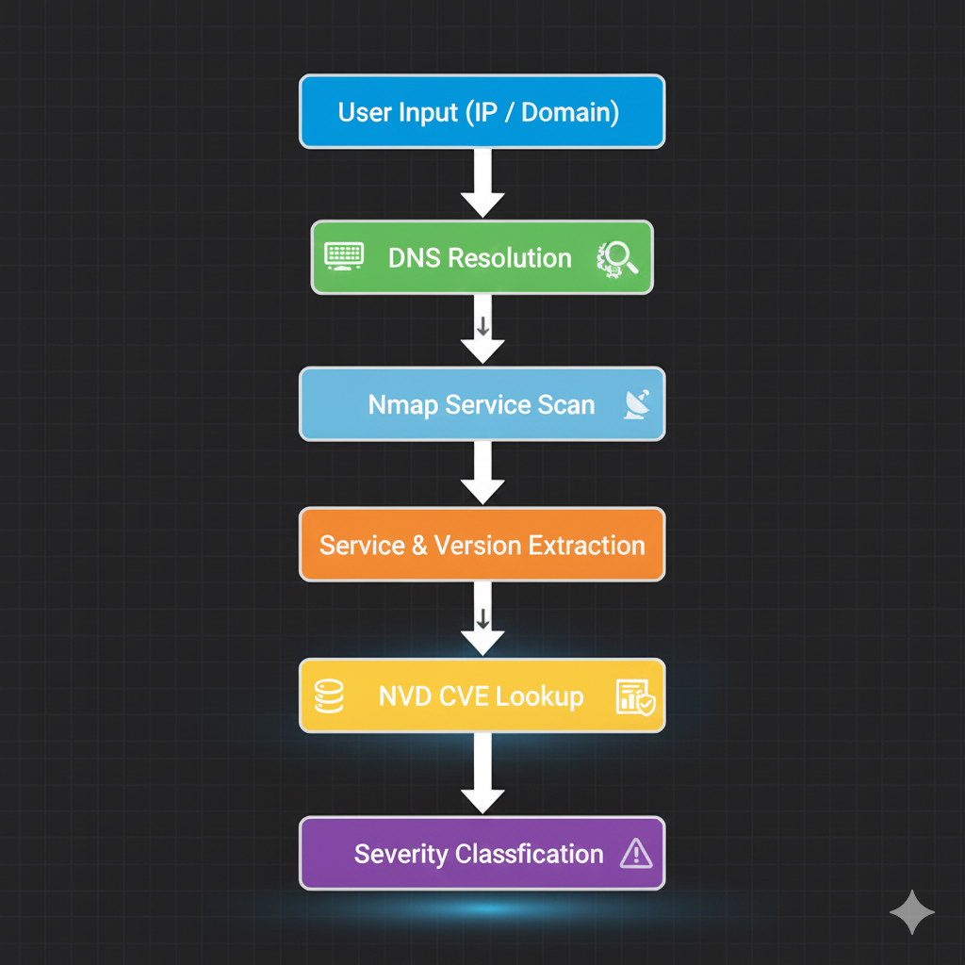

8. IMPLEMENTATION DETAILS
Service Detection
The scanner uses Nmap’s -sV flag to detect running services and their versions.
CVE Matching
The NVD API is queried using detected service names. The scanner retrieves:
- CVE ID
- CVSS score
- Severity level
Severity Levels
CVSS Score | Severity
0.1 – 3.9 | Low
4.0 – 6.9 | Medium
7.0 – 8.9 | High
9.0 – 10 | Critical

9. TESTING & RESULTS
Test Environment:
- Metasploitable2 (local virtual machine)
- scanme.nmap.org (public allowed test host)
Sample Result (Metasploitable2):
IP Address | Port | Service | Version | CVE | Severity
192.168.56.101 | 21/tcp | FTP | vsftpd 2.3.4 | CVE-2011-2523 | Critical
192.168.56.101 | 22/tcp | SSH | OpenSSH 4.7p1 | CVE-2008-5161 | High

10. RESPONSIBLE DISCLOSURE & ETHICS
This project strictly follows ethical guidelines:
- Only authorized systems were scanned
- No exploitation of vulnerabilities was performed
- Results were used for educational purposes only, Public websites were not targeted
Responsible disclosure ensures vulnerabilities are reported safely without harming systems or users.

11. LIMITATIONS OF THE PROJECT
- CVE detection depends on accurate service banners
- Updated systems may show no vulnerabilities
- False positives are possible
- Does not perform deep vulnerability assessment

12. SCREENSHOTS
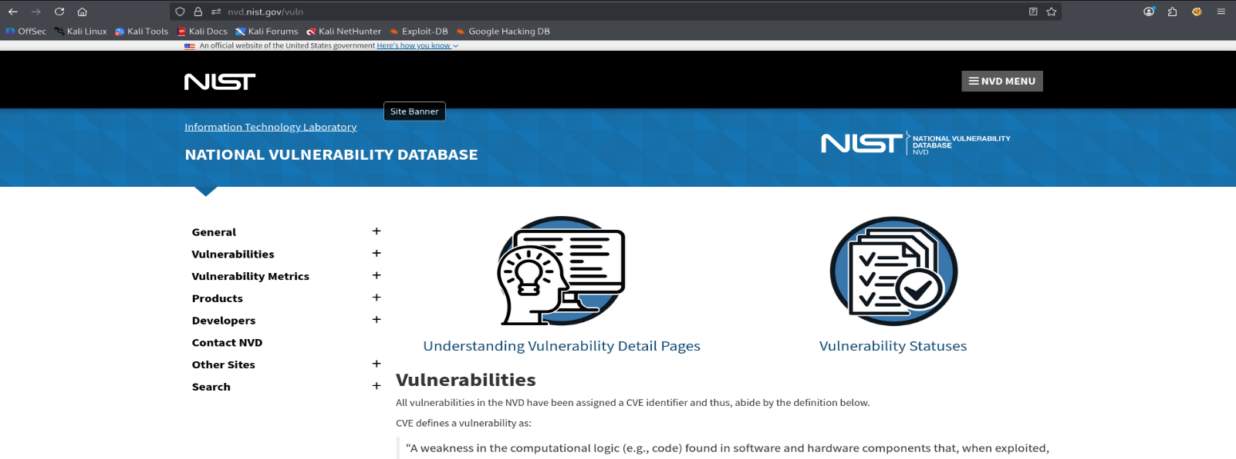

Excution Program:
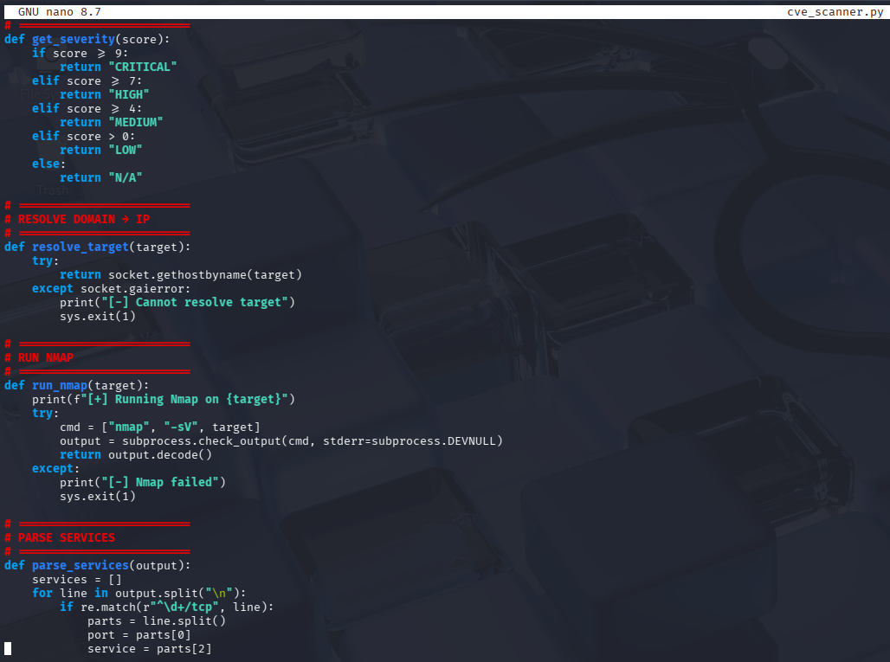
Sample test: # I use my own Metasploitable2 machine to test CVEs
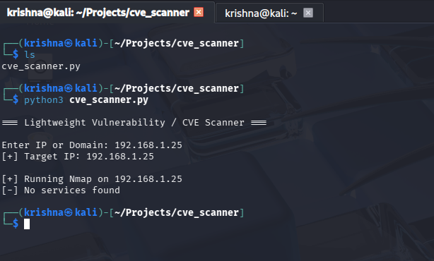
Successful Scanning CVEs:
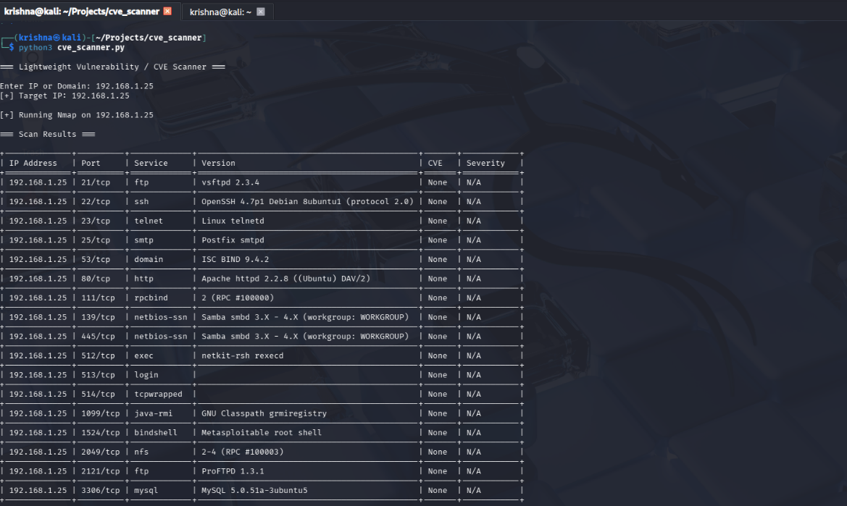

13. CONCLUSION
The Vulnerability / CVE Scanner successfully demonstrates how security tools identify vulnerabilities based on known databases. The project highlights the importance of patch management and secure configurations while providing hands-on experience with real-world security assessment techniques.
This project serves as a foundation for further learning in cybersecurity, penetration testing, and defensive security practices.

14. REFERENCES
- https://nvd.nist.gov
- https://nmap.org
- https://www.kali.org
- https://owasp.org

